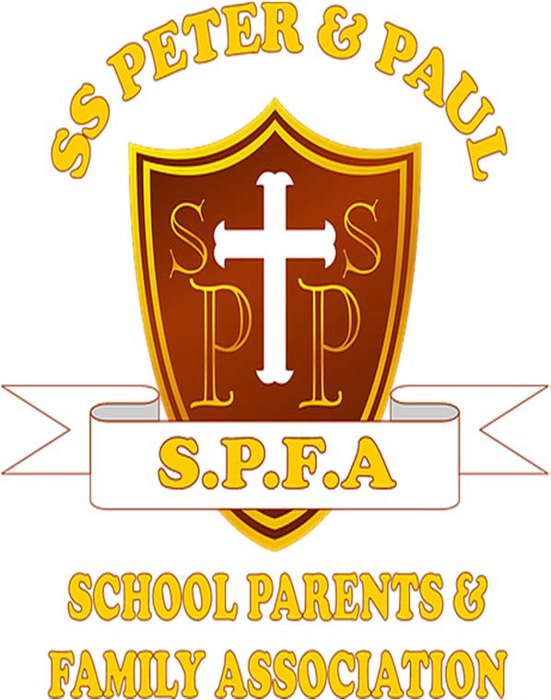

CASH HANDLING AND PROCEDURES POLICY

Policy Date | March 2025
Policy Audit | March 2026/Annually
Policy Review/Cycle Date | March 2027/Every 2 Years
Responsibility of | SPFA Chair
Responsibility of | SPFA Deputy Chair
Responsibility of | SPFA Treasurer

Document Control Sheet

Version | Date | Comments | Approved By
1.0 | March 2018 | Initial version issues for review and approval

- Scope of the Policy
The purpose of this document is to ensure the safe handling of cash receipts. The policy is aimed at ensuring all School Parent Family Association (SPFA) committee members and volunteers know and are confident about handling any cash received. The policy is in accordance with the requirements of the Charity Commission.

This policy should be distributed to all SPFA Committee members and volunteers involved in collecting money.

Policy Statement
The policy is designed to provide the internal controls needed in this area for the protection of the charity, committee members, volunteers and the trustees who are fundamentally responsible for control of the charity’s activities and funds.

All cash handled by SPFA members and volunteers, must be dealt with so as to ensure its safe custody and mitigate against loss whether through fraud, misappropriation or mistake.

This is part of the obligation of trustees and committee members to ensure that all assets are used for the benefit of the charity, whether from donations or cash earned on behalf of the charity.

Procedure

  - Recording of Cash Collection
Following any event where cash is collected on behalf of SPFA at the earliest opportunity all cash should be handed to either the SPFA Chair/Deputy Chair or Treasurer with a completed SPFA Deposit Form (Appendix A).
All cash must be counted by two people consisting of either the SPFA Chair/ Deputy Chair/Treasurer and the relevant deposit form will be signed. The Treasurer is responsible for ensuring all approved deposits are recorded accurately on the relevant finance spreadsheet prior to banking. Deposit forms will be retained by the Treasurer.

Banking will be carried out by either the SPFA Chair/Deputy Chair or Treasurer.
Where requested a signed, duplicate, pre‐numbered receipt/acknowledgement can be provided. The copy of the receipt shall remain in the receipt book held by the Treasurer. Receipt books should be kept for the current year and for the two preceding years.

Reimbursement Request Process
Reimbursement requests must be submitted within 30 days of expenditure. Reimbursement requests older than 30 days will require signed approval of the SPFA Chair/Deputy Chair and Treasurer following agreement at the next scheduled SPFA Committee meeting.

Any requests for reimbursement should be submitted using the SPFA Reimbursement Request Form (Appendix B). Requests must be accompanied with a receipt showing details of expenditure. Reimbursement requests forms are to handed to either the SPFA Chair/Deputy Chair/Treasurer.

Reimbursement requests will be processed on a monthly basis following the SPFA Committee meeting (currently scheduled to take place the last Tuesday of every month).

Where cash is not available within petty cash arrangements will be made for a cheque to be processed. In such circumstances the cheque number, amount and date will be recorded on the original reimbursement request form. The Treasurer will then record this information of the relevant finance spreadsheet.

All deposits and requests for reimbursements must be accompanied by a completed deposit/reimbursement form. No money should be removed from the amount raised. Full amount should be deposited; reimbursements will be made in either cash or cheque after completion of finance spreadsheet.

Events
Records are maintained for each fundraising event, in sufficient detail to identify gross receipts and costs incurred.

Ticketed Events
For ticketed events the following controls should be in place:
    - Tickets are prenumbered
    - A record is kept of all persons who have been issued with tickets to sell, and the ticket numbers that have been allocated to each person
    - A record is kept of which tickets have been sold
    - All money from tickets and any unsold tickets are collected; and
    - A reconciliation is made of receipts against tickets sold by the SPFA Chair/Deputy Chair/Treasurer

Banking
Cheques/Cash should be paid into the bank as soon as reasonably practicable. SPFA members and volunteers should be aware that cash over £1,000 is not insured in a private residence, and that only amounts up to £5,000 are insured in transit. Wherever possible cash/cheques totalling excess of £1,000 should be banked. Cash where possible should be kept in a safe until appropriate to bank.

The Bank should be reconciled regularly, identifying any standing orders, direct debits, credit/debit card receipts.

All donations are to be recorded on the relevant finance system.

Duties for recording, reconciliation and banking of cash should be monitored monthly and checked to ensure that all cash received has been paid into the bank, and there is an audit trail for all cash receipts.

Safety of SPFA Committee Members /Volunteers
When banking or collecting cash the safety of SPFA members/volunteers is paramount. SPFA members and volunteers should on no account put themselves into situations of danger, and should give up/not seek to recover cash or valuables if in physical danger.
Staff should follow the guidelines below to determine how many people are required to take money to the bank:

£Nil | £2,500 | 1 person
£2,501 | £5,000 | 2 people
£5001 | £7,500 | 3 people
£7,501 | £10,000 | 4 people
£10,000+ | Refer to Insurer

The above policy should be viewed as especially cash relating to cash rather than cheques made out to School Parent Family Association (SPFA).
To mitigate the risk of theft by a third party, the time and day of banking should be varied.

Communication
All SPFA Committee Members and volunteers will be informed of the above guidance and new members will made aware of the Cash Handling Policy.

Audit & Review
This policy will be audited on an annual basis and reviewed in two years’ time or sooner should legislation or audit dictate such a review.

Appendix A

SPFA Deposit Form

SPFA Deposit Form

Event |  | Stall/Activity/  Donation
Total Cash |  | Total Cheques
Verified By
Chair |  | Treasurer
Date |  | Date

Appendix B

SPFA Reimbursement Request Form

SPFA Reimbursement Request
Note: Completed forms to be returned with associated receipts to Chair/Treasurer

Requested By |  | Date
Amount of reimbursement |  | No. of Receipts Attached
Description of expense
Item No. |  | Approved by
Signature

Amount approved |  | Cheque/Cash
Issue Date

