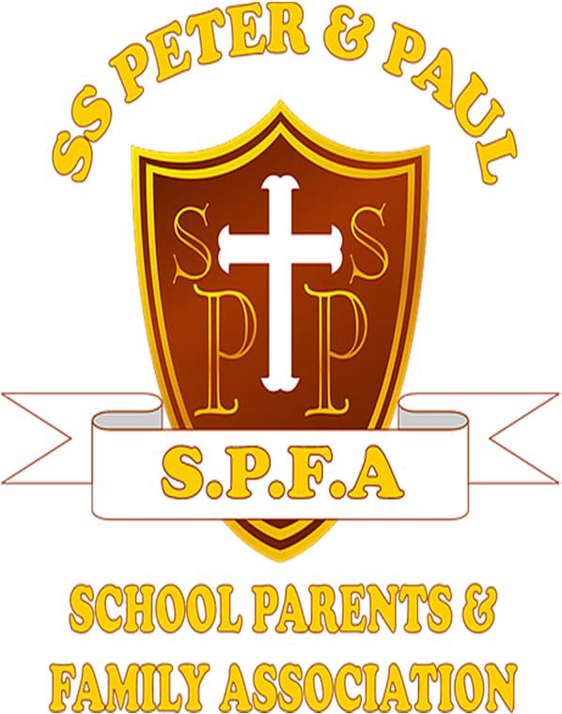

School Parent Family Association (SPFA) Governance Policy

Policy Date | March 2025
Policy Audit | March 2026/Annually
Policy Review/Cycle Date | March 2027/Every 2 Years
Responsibility of | SPFA Chair
Responsibility of | SPFA Deputy Chair
Responsibility of | SPFA Treasurer

Document Control Sheet

Version | Date | Comments | Approved By
1.0 | March 2018 | Initial version issues for review and approval

- Introduction
The purpose of this document is to describe how the School Parent Family Association (SPFA) is managed & run.

Objectives
The main objectives of the SPFA are to:
- Provide facilities or equipment which support the school and advance the education of its pupils. This is generally achieved through fund raising.
- Develop effective relationships between staff, parents and others associated with the school.

Membership
All parents/guardians of children at the school, as well as anyone employed by the school, are automatically members of the SPFA. All are welcome and encouraged to attend any meetings.
There are three types of elected membership of the SPFA and together they make up the SPFA Committee. They serve for two years.

Officers
Every two years’ officers are elected at the SPFA Annual General Meeting (AGM) and it is their job to manage the SPFA. See page 4 for Officer’s roles and responsibilities.

Committee Members
Each year parents/guardians sign up as Committee Members at the SPFA AGM held at the beginning of the school year. It is their role to attend meetings and support the work of the SPFA by offering their time and expertise. On occasions where the number of parents/guardians exceeds fifteen, Committee Members will be elected. Those unsuccessful in becoming Committee Members will be recorded as a Co‐opted Committee Members. Committee Members will be signed up to the Parentkind (formally known as PTA UK) website via the SPFA Chair/Deputy Chair.

Co‐opted Committee Member
In addition to the above, a number of additional members may be elected as Co‐opted Committee Members. They may be elected at the AGM or during the year by the Committee and should serve until the end of the year. It is their role to attend meetings or support the work of the SPFA if additional help is required.

Communication
Regular communication between Officers, other members and the Headteacher is essential to the smooth running of the SPFA and its activities. This should be achieved through:
- Regular meetings (see below)
- Regular updates of the progress of activities from the Officers to other members
- Use of email, noticeboard, newsletters, SPFA Facebook page and SPFA WhatsApp page

Meetings
Generally, there are four types of meeting held each year.

Annual General Meeting (AGM)
The AGM should be held annually, at the beginning of the school year. At this meeting attendees should:
    - Receive accounts for the previous year
    - Receive a report on activities since the previous AGM
    - Elect the Officers, Committee Members and Co‐Opted Committee Members for the forthcoming year
    - Appoint an independent examiner/auditor for the SPFA

Full SPFA Meeting
A full SPFA meeting should be held each month where all members are invited. At this meeting members should:
    - Receive updates on progress of activities since the last meeting
    - Decide how to progress outstanding events/activities
    - Discuss and resolve any other issues arising

Sub‐Committee Meeting
Sub‐Committee meetings should be held when required and should be used for planning and organising any specific forthcoming events with those involved.

Officer/Headteacher/Deputy Headteacher Meeting
These meetings should generally occur once per term and be used to update the Headteacher/Deputy Headteacher with progress and provide an opportunity to discuss any issues that have arisen since the previous meeting. The Headteacher/Deputy Headteacher will ensure that planned events comply with government policy and health and safety regulations etc. The SPFA Chair/Deputy Chair and Treasurer should attend this meeting.

The date and agenda of any meeting should be sent out two weeks in advance so that members can make arrangements to attend or send their views in advance of the meeting if they cannot attend. Minutes should be distributed within two weeks and actions followed up.

Decision Making
The main decisions affecting activities of the SPFA should be made at the AGM or Full SPFA meetings. This includes decisions relating to what events are to be run during the year and how funds raised will be spent. In order for a decision to be made, there must be present at least two Elected Officers (SPFA Chair/Deputy Chair/Treasurer) and a Committee Member from each year group. Should a Committee Member from each year group not be in attendance, a decision will still be made. On occasion it may also be necessary for the Chair and Deputy Chair to make a decision away from any of the above forums. Any members wishing to vote on a decision must be present at the meeting. Everyone present has one vote, with the exception of the Chair who has a second or casting vote.

Roles and Responsibilities – Officers

  - SPFA Chair
    - Provide leadership and ensure the Committee fulfils its role in respect of governance of the association
    - Sign the approved minutes of the last meeting
    - Set the agenda for the meetings alongside the Deputy Chair
    - Ask for apologies for absence, ensure the agenda is followed and that all business is covered
    - Call the meeting to order when necessary
    - Agree a date for the next meeting with the members
    - Close the meeting
    - Write the annual report
    - Get to know Committee Members and welcome and involve new members
    - Sign cheques for the SPFA with one other Committee Member

Secretary
    - Deal with correspondence
    - Call meetings – giving plenty of notice
    - Prepare and distribute agendas
    - Keep a record of attendance at meeting and ensure that enough Committee Members are present to make the meeting quorate
    - Take notes during the meetings, write minutes and distribute in a timely manner to the members
    - Ensure actions taken at meeting are discharged
    - Make meeting and event arrangements

SPFA Deputy Chair
    - Support the Chair with some or all of the Chair activities

Treasurer
    - Maintain accurate and detailed financial records
    - Prepare and Co Sign Cheques if required
    - Present a financial report at each meeting
    - Provide and account for cash floats at events
    - Liaise with the bank
    - Charity Registration and Gift Aid
    - Make approved payments
    - Pay agreed expenses
    - Prepare annual accounts and liaise with the independent examiner of accounts
    - Count and bank ALL monies along with one other Elected Officer
    - Ensure the Committee Members have agreed appropriate procedures for the handling of financial matters
    - Update, Manage and Distribute the Cash Handling Policy to all Committee Members and Volunteers

Audit & Review
This policy will be audited on an annual basis and reviewed in two years’ time or sooner should legislation or audit dictate such a review.

